D212: Data Mining II – Task 3
IT Department, WGU
By Andrew Fagundes
Professor Kesselly Kamara
October 25th, 2025

Table of Contents
Part I: Research Question 2
A1: 2
A2: 3
Part II: Market Basket Justification 4
B1: 4
B2: 4
B3: 5
Part III: Data Preparation 5
C1: 5
C2: 5
C3: 6
C4: 7
Part IV: Data Summary and Implications 8
D1: 8
D2: 9
D3: 10
References (No third-party code references used) 11

Part I: Research Question

A1:
Can market basket analysis identify typical prescriptions associated with patients?

A2:
This analysis will help find relationships between commonly identified medications that appear together. This is important because it reveals hidden co-purchasing patterns that are not obvious from the prescription data set. By examining commonly prescribed medications, we can understand why those prescriptions are prescribed. MBA can help identify product bundles, cross-selling opportunities, or complementary items from the prescription data set.

Part II: Market Basket Justification

B1:
Market Basket Analysis uses association rules to describe patterns like, “If a customer buys X, they are likely to buy Y.” X is considered the antecedent, the item(s) the customer buys first. Y is considered the consequent, the item(s) likely to be bought with X. These items are considered the “basket”, which is used to define “association rules.” Three key metrics are used to quantify how strong and useful each association rule is. Support illustrates how frequently the itemset (X, Y) appears in all transactions. Confidence indicates the likelihood a customer will buy Y given the purchase of X. Lift measures how much more likely Y is bought when X is bought, compared to random chance. If lift = 1, X and Y are independent. If lift is greater than 1, there is a positive association that buying X increases chance of Y. If lift is less than 1, there is a negative association that buying X reduces chance of Y. With these association rules, hospitals can understand which medications increase the likelihood of higher-risk conditions and reduce readmission rates by changing prescription patterns. MBA is expected to identify frequently prescribed medication combinations, detect prescription patterns for readmitted patients, and optimize medication protocols.

B2:
Each row represents a patient’s medical record, with columns indicating the receipt of medication. Here’s an example transaction for a patient’s medications:
This patient was prescribed citalopram, Benicar, and amphetamine salt combo xr. The rest of the columns do not contain any medications. This patient potentially has depression, ADHD, and high blood pressure. MBA will analyze how often these conditions occur together in multiple patients to find a strong association that increases the risk of depression or frequent emergency visits.

B3:
Market basket analysis assumes that transactions are independent. Each patient’s prescription set is independent, meaning one patient’s prescriptions don’t affect another. Patients with similar medical conditions often receive similar treatments, with some prescriptions based on medical guidelines. MBA identifies crucial relationships in prescribing patterns, guiding better decision-making for education management.

Part III: Data Preparation

C1:
The prepared dataset in CSV format is in the attached ‘D212_Task3_Data.csv’.

C2:
The apriori algorithm scans transaction data to find frequent itemsets (high support), generates association rules between items, and filters rules based on minimum support, confidence, and lift thresholds. The output is an association rules table with support, confidence, and lift for each rule. The code below executes the apriori algorithm without errors, generating association rules between medications. 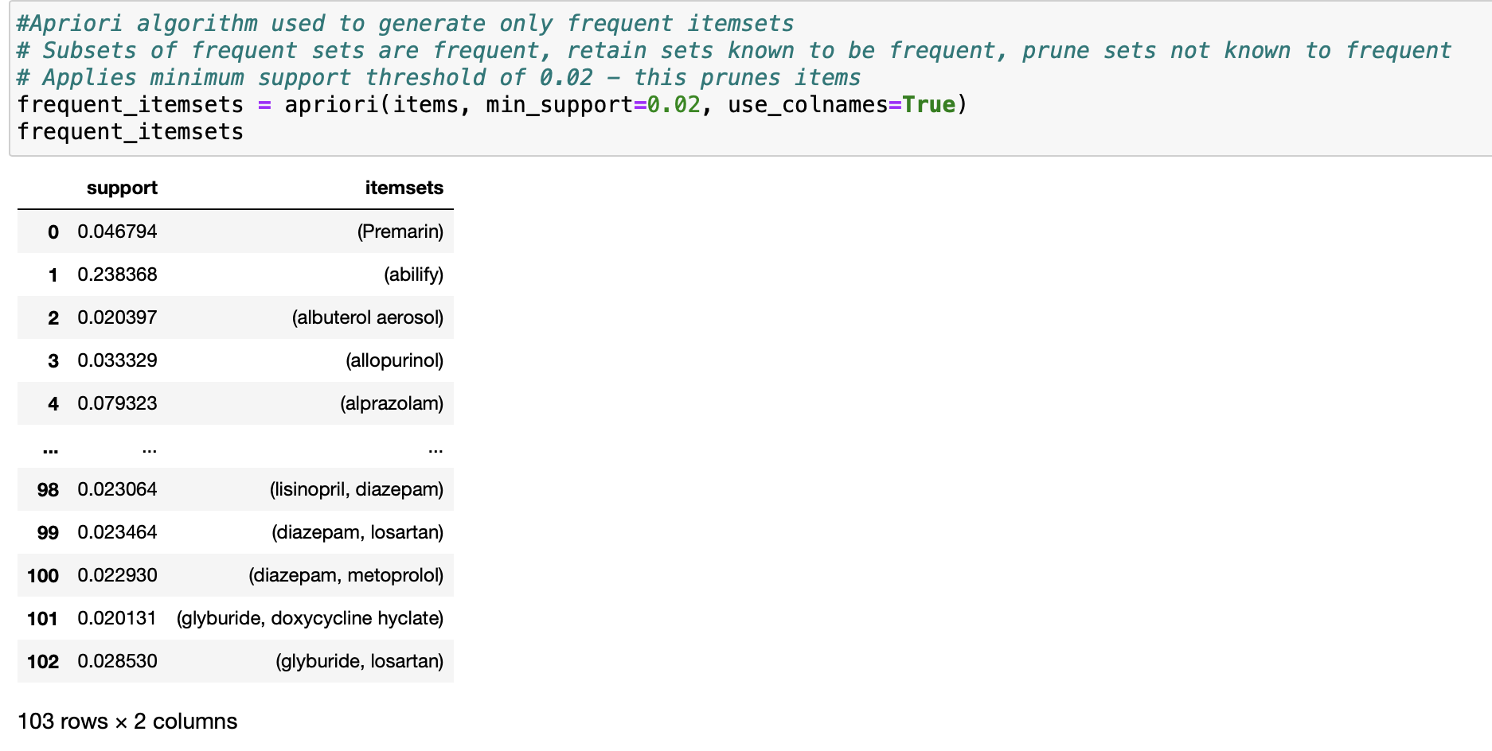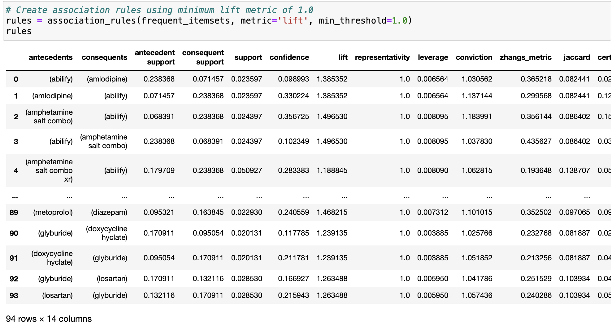

C3:
The Apriori algorithm used a minimum support value of 0.02, meaning itemsets must appear in at least 2% of all transactions (about 150 out of 7501). After creating the itemsets table, an association rules table was generated using its data. The table used ‘lift’ as a metric with a minimum threshold of 1.0. This threshold allowed rules showing a positive association between antecedent and consequent itemsets, where the purchase of the antecedent increases the likelihood of the consequent being purchased.
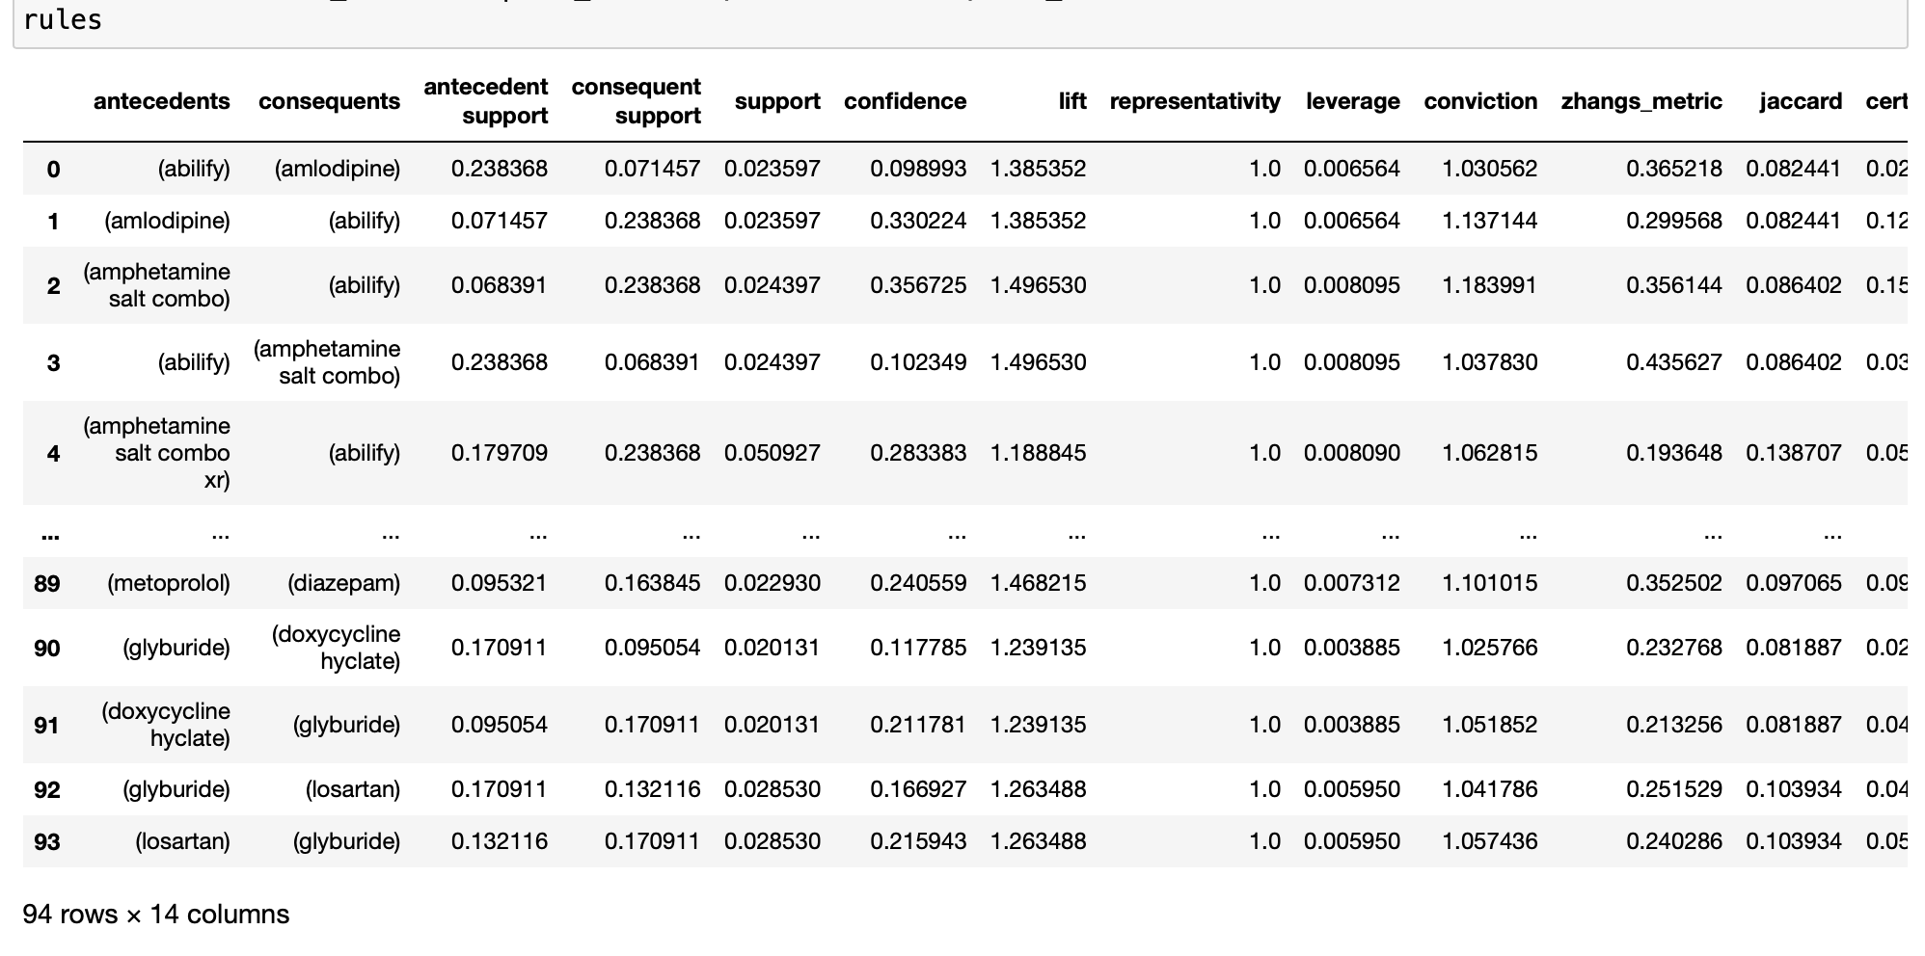
In this output for support, if abilify and amlodipine appear in 2.3% of transactions, then support = 0.023597. In this output for confidence, a confidence of .09 means that when abilify is prescribed, amlodipine is prescribed about 9% of the time. Lastly, a lift of 1.38 indicates that Abilify is 1.38 times more likely to be prescribed when Amlodipine is prescribed, compared to random prescribing.

C4:
The top three rules were chosen using confidence as the primary metric, ranging from 0 to 1, with 1 indicating the highest confidence. Confidence explains the probability of the consequent being purchased given the antecedent was purchased (Lim 2022). With confidence scores between 0.4 and 0.45, Abilify is likely prescribed, given prescriptions of metformin, glipizide, or lisinopril. Lift scores exceeding 1 suggest positive associations between items (Lim 2022).
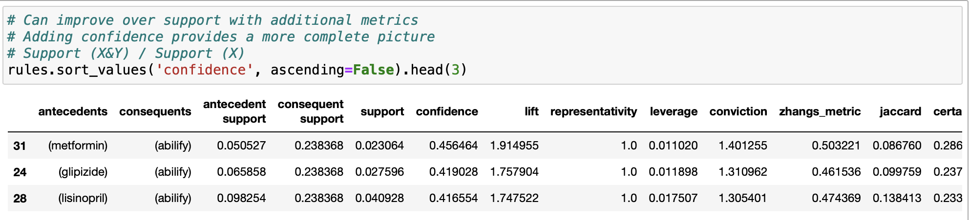

Part IV: Data Summary and Implications

D1:
Support measures the basic probability of an event to occur (Lim 2022). It is measured by the proportion of transactions in which an item set appears (Lim 2022). In other words, support (A) is the number of transactions which includes A divided by the total number of transactions (Lim 2022). Metformin and abilify appear together in 2.3% of transactions, glipizide and abilify in 2.7%, and lisinopril and abilify in 4.0%.
Lift is the observed to expected ratio (Lim 2022). Lift measures how likely an item is purchased when another item is purchased, while controlling for how popular both items are (Lim 2022). It can be calculated by dividing the probability of both items occurring together by the product of the probabilities of both individual items occurring as if there was no association between them (Lim 2022). A lift of 1 will then mean that both items are independent and without any association (Lim 2022). For any value higher than 1, lift shows that there is an association (Lim 2022). The higher the value, the higher the association (Lim 2022). The top three rules have lift values greater than one, suggesting positive association between the items and implying that initial prescriptions increase the likelihood of an Abilify prescription.
The confidence of a consequent event given an antecedent event can be described by using conditional probability (Lim 2022). Simply put, it is the probability of event A happening given that event B has already happened (Lim 2022). This can be used to describe the probability of an item being purchased when another item is already in the basket (Lim 2022). It is measured by dividing the proportion of transactions with item X and Y, over the proportion of transactions with Y (Lim 2022). This value ranges from zero to one, with one indicating the highest confidence. Given the initial prescriptions of metformin, glipizide, or lisinopril, Abilify is reasonably likely to be prescribed with confidence scores between 0.4 and 0.45.

D2:
Abilify, accounting for about 9% of all transactions, appears in 24% of prescriptions, including metformin, glipizide, and lisinopril, medications for diabetes and high blood pressure, respectively (Mayo Foundation for Medical Education and Research, 2024; drugs.com, n.d.). Abilify, a medication for mental health disorders like schizophrenia and bipolar disorder, is the next medication (Cleveland Clinic, 2024). Despite the lack of clear patterns between antecedent and consequent prescriptions, Abilify prescriptions are frequent. This suggests the patient population may have mental health issues.

D3:
Further research is suggested to determine the underlying reason for the pattern of an Abilify prescription after metformin, glipizide, or lisinopril. The number of transactions with an Abilify prescription may indicate a mental health crisis among patients. Further research on the causes could be helpful. Investing in mental health care could also be beneficial.

References (No third-party code references used)
Cleveland Clinic. (2025). Abilify (Aripiprazole ): Uses & side effects. Cleveland Clinic. https://my.clevelandclinic.org/health/drugs/19695-aripiprazole-tablets
Lisinopril uses, dosage, side effects & warnings. Drugs.com. (2024, Feb 29). https://www.drugs.com/lisinopril.html
Mayo Foundation for Medical Education and Research. (2025, July 1). Glipizide and metformin (oral route) description and brand names. Mayo Clinic. https://www.mayoclinic.org/drugs-supplements/glipizide-and-metformin-oral-route/description/drg-20061984#:~:text=Glipizide%20and%20Metformin%20combination%20is,excess%20sugar%20for%20later%20use.
Lim, Yenwee (2022, April 8). Data Mining: Market Basket Analysis with Apriori Algorithm. Towards Data Science. https://towardsdatascience.com/data-mining-market-basket-analysis-with-apriori-algorithm-970ff256a92c/

